**Create Views**

CREATE VIEW Client_Addresses AS

SELECT ClientID, ClientFirstName, ClientLastName,

(Street1 + IIF((Street2 IS NOT NULL), ' ' + Street2, '')

+ ', ' + City + ' ' +

IIF((State IS NOT NULL), (State + ' ' + CONVERT(varchar, Zipcode) + ', '), '')

+ Country) AS Address

FROM Client INNER JOIN ADDRESSES ON ClientAddress=AddressID

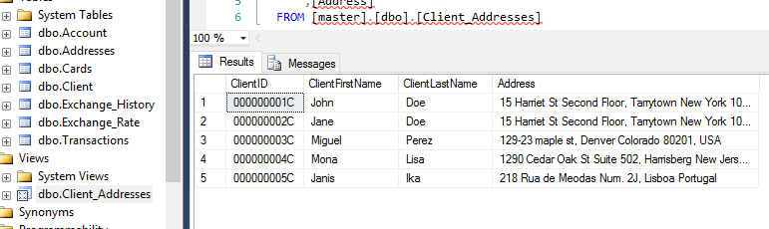

CREATE VIEW Cards_Accounts AS

SELECT Account.AccountID, Cards.CardID FROM Account INNER JOIN Cards ON Cards.AccountID=Account.AccountID;

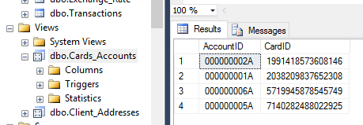

**Stored Procedures**

CREATE PROCEDURE RateChanges @y AS smallint, @m AS tinyint AS

SELECT AccountID, AccountBalance, (AccountBalance*EUR_Change) AS 'Euro Change'

FROM Account, Exchange_History WHERE MONTH(Percent_Month_ID)=@m AND YEAR(Percent_Month_ID)=@y

ORDER BY AccountID ASC;

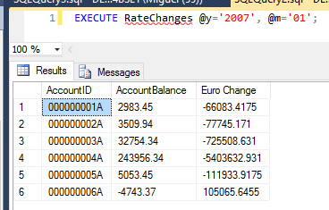

CREATE PROCEDURE RateComparisons @y AS smallint, @m AS tinyint

AS

SELECT EUR_Change, EUR_Rate, GBP_Change, GBP_Rate, CAD_Change, CAD_Rate, AUD_Change, AUD_Rate, JPY_Change, JPY_Rate, CNY_Change, CNY_Rate

FROM Exchange_Rate, Exchange_History WHERE MONTH(Percent_Month_ID)=@m AND YEAR(Percent_Month_ID)=@y AND Percent_Month_ID=Rate_Month_ID

ORDER BY Percent_Month_ID DESC;

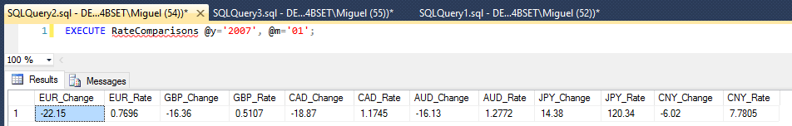

**Triggers**

CREATE TRIGGER DuplicateInExchangeHistory ON Exchange_Rate

AFTER INSERT

AS

DECLARE @MonthID AS date = (SELECT Rate_Month_ID FROM inserted)

DECLARE @EUR AS float = ((((SELECT EUR_Rate FROM inserted)-0.9886)/0.9886)*100)

DECLARE @GBP AS float = ((((SELECT GBP_Rate FROM inserted)-0.6106)/0.6106)*100)

DECLARE @CAD AS float = ((((SELECT CAD_Rate FROM inserted)-1.4477)/1.4477)*100)

DECLARE @AUD AS float = ((((SELECT AUD_Rate FROM inserted)-1.5227)/1.5227)*100)

DECLARE @JPY AS float = ((((SELECT JPY_Rate FROM inserted)-105.21)/105.21)*100)

DECLARE @CNY AS float = ((((SELECT CNY_Rate FROM inserted)-8.2792)/8.2792)*100)

INSERT INTO Exchange_History VALUES (@MonthID, @EUR, @GBP, @CAD, @AUD, @JPY, @CNY)

GO

-- I realized I had a math error much later on because it was off by a factor of ten, I switched from *10 to *100

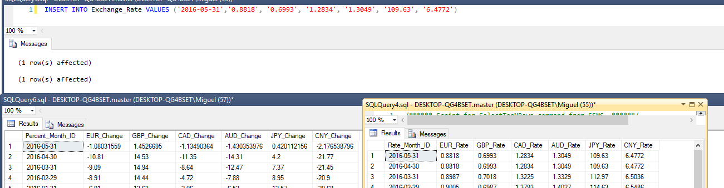

CREATE TRIGGER UpdateCNYRate ON Exchange_History

FOR UPDATE

AS

UPDATE Exchange_Rate

SET CNY_Rate = (SELECT (CNY_Rate) FROM Exchange_Rate WHERE Rate_Month_ID='2000-01-31') *

(1+((SELECT (Exchange_History.CNY_Change) FROM Exchange_History, inserted

WHERE Exchange_History.Percent_Month_ID = inserted.Percent_Month_ID)/100))

FROM inserted WHERE Exchange_Rate.Rate_Month_ID = Percent_Month_ID

GO

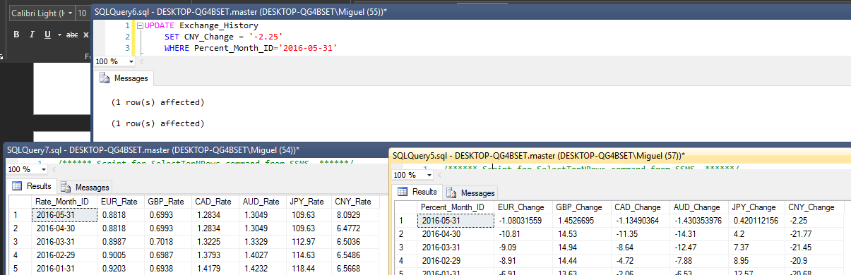

**Using External XML Script**

DECLARE @x XML

SELECT @x=P FROM OPENROWSET(BULK '~filepath~', SINGLE_BLOB) AS Products(P)

DECLARE @hdoc int

EXEC sp_xml_preparedocument @hdoc OUTPUT, @x

UPDATE Exchange_Rate

SET EUR_Rate = (SELECT EUR FROM OPENXML (@hdoc, '/root/Exchange_Rate', 2) WITH (EUR money)),

GBP_Rate = (SELECT GBP FROM OPENXML (@hdoc, '/root/Exchange_Rate', 2) WITH (GBP money)),

CAD_Rate = (SELECT CAD FROM OPENXML (@hdoc, '/root/Exchange_Rate', 2) WITH (CAD money)),

AUD_Rate = (SELECT AUD FROM OPENXML (@hdoc, '/root/Exchange_Rate', 2) WITH (AUD money)),

JPY_Rate = (SELECT JPY FROM OPENXML (@hdoc, '/root/Exchange_Rate', 2) WITH (JPY money)),

CNY_Rate = (SELECT CNY FROM OPENXML (@hdoc, '/root/Exchange_Rate', 2) WITH (CNY money))

WHERE Rate_Month_ID = (SELECT Month_ID FROM OPENXML (@hdoc, '/root/Exchange_Rate', 2) WITH (Month_ID date))

EXEC sp_xml_removedocument @hdoc

-- XML FILE (final.xml)

<root>

<Exchange_Rate>

<Month_ID>2016-05-31</Month_ID>

<EUR>0.8819</EUR>

<GBP>0.6994</GBP>

<CAD>1.2835</CAD>

<AUD>1.3050</AUD>

<JPY>109.64</JPY>

<CNY>8.0930</CNY>

</Exchange_Rate>

</root>

